River Oaks Elementary
Kindergarten School Supply List
2023-2024
Welcome to Kindergarten! We look forward to a great year of learning.
Labeled backpack or book bag (large enough for library books, folders, and a tablet.)

Please do NOT label the following items:
- 4 plastic folders with prongs (1 red, 1 blue, 1 green, 1 yellow) plain NOT decorated
- 1 pair of scissors
- 2 boxes of thin crayons (24 count)
- 20 glue sticks
- 1 pack of pencils (10 or 12 count) (sharpened please)
- 1 (4 pack) expo dry-erase markers
- 1 box of 8-10 count thin markers
- 1 box (10 count) thick markers
- 1 container of Play-Doh Brand Play-Doh (other brands may contain peanut oil/ some students may have allergies)
- 1 pencil/crayon holder box (see below)

Optional donations
- Girls-(1 box sandwich sized Zip Lock bags)/ Boys-( 1 box gallon sized Zip lock bags)

All students must have a change of clothes (pants, shirts, underwear, and socks) in a gallon size bag in his/her backpack all year long in case of accident/spills.
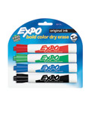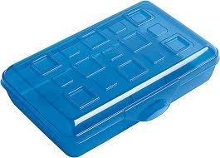
Pencil/crayon box
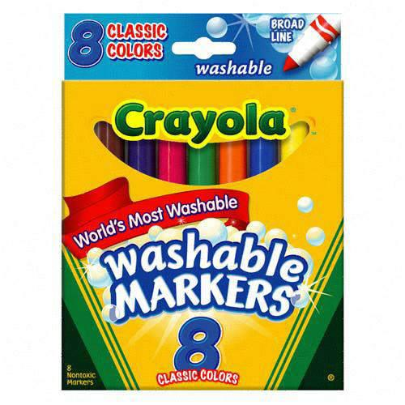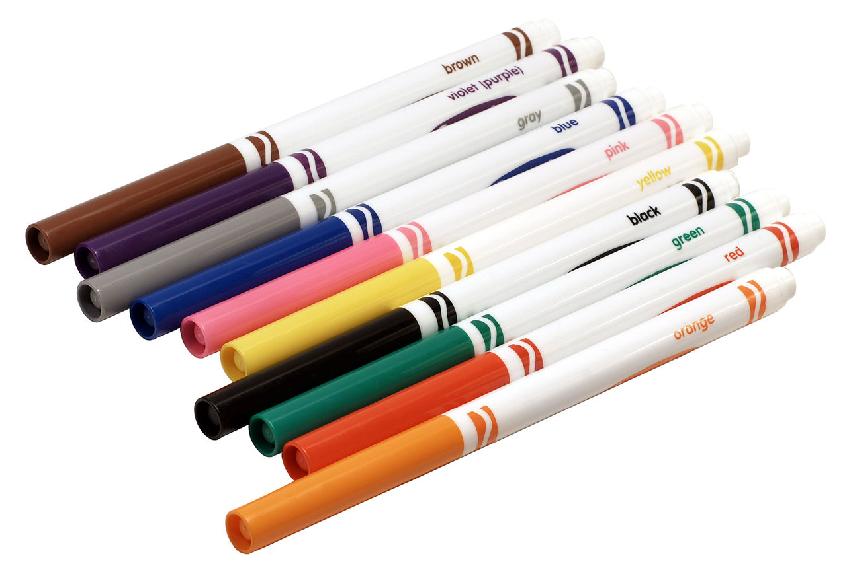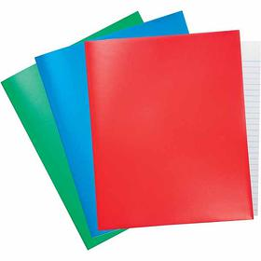
8 or 10 pack
4 dry erase markers
8 or 10 thin markers
Plastic ones have been found at Walmart or Target.

