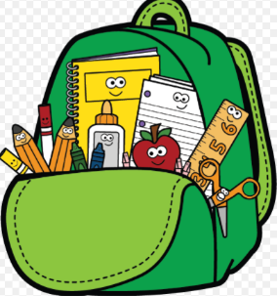
River Oaks Elementary
Third Grade Supply List
2023-2024

We are looking forward to seeing you back in school! We can’t wait to see your smiling faces soon!
The following is the suggested supply list you will need. We are asking that these items are to be bought exactly as listed since each item serves a specific purpose in the classroom. Throughout the year we may run low on some supplies so we suggest that you might want to buy extra of the highly used items (like pencils, glue sticks, etc.) to send in later in the year. Most supplies will be collected and used as community supplies, such as notebook paper, dry erase markers, highlighters, pencils, and glue sticks.
THANK YOU FOR YOUR SUPPORT!

- Backpack large enough to hold a laptop (13 X 9 X1)
- Composition Books (7)
  - (red,blue,yellow,green) or (ALL BLACK) (NO PICTURES)
- 6 solid-colored folders
  - (MUST BE red, blue, green, yellow, purple, and orange) **Please get the folders that ONLY have pockets and no metal prongs in the middle)
- 4 Highlighters
- Pencils – 2 boxes of 24 pencils (#2 lead)
- 1 PLASTIC Pencil BOX
- Glue sticks (12)
- Scissors
- Lined paper
- Over the ear headphones
- 1 pack of thin markers
- 4 packs of dry erase markers – thin (skinny) size
- 1 ruler with inches and centimeters

Optional Donations
- Sandwich size baggies
- Gallon size baggies
- Hand sanitizer
- Tissues

Contact Information: River Oaks Elementary 703-441-0050
Ms. N. Carew: carewnna@pwcs.edu

